**RFID**

RFID (Radio-Frequency Identification) technology is widely used for tracking and identifying objects or assets in various industries, including retail, logistics, healthcare, and manufacturing. RFID systems typically consist of several components and follow specific protocols.

Here, we will discuss RFID protocols with architectural details:

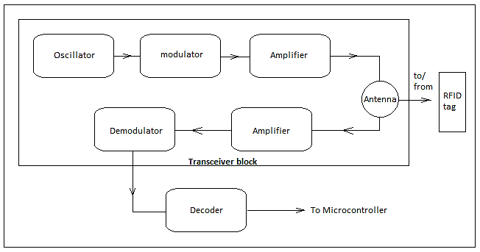

Block diagram of a RFID system

**RFID System Components:**

* RFID Tags: These are small electronic devices containing a microchip and an antenna. Tags are attached to objects or assets for identification.

It consists of the following two components (in case of a passive tag):

* + Microchip: It is a semiconductor device which consists of a circuit etched in it with some KB of memory storage, capable of storing data and transmitting it whenever needed.
  + Antenna: It is used to transmit the data that is present in the chip into air so that it can be detected by a reader.

In case of an active tag it consists of Microchip, battery, and an antenna.

* + Battery:  In active devices to power up the microchip battery is externally used.
* RFID Readers (Interrogators): Readers emit radio waves to communicate with RFID tags. They can read and write data to tags. It consists of the followings:
  + Transceiver: It can be used either as a transmitter or a receiver. It consists of an oscillator to generate a continuous signal which is modulated to a required frequency and then transmitted into air through an antenna.
  + Antenna: It is a device which converts the electrical signal into electromagnetic signal which is efficient in propagating the signal in air.
  + Decoder: When a RF signal is detected at the antenna from a tag, the decoder helps in retrieving the data.
* Middleware: Middleware software connects RFID readers to enterprise systems, managing data exchange and processing.
* Enterprise Systems: These systems store and manage data collected from RFID readers. They can include databases, inventory management, and supply chain software.

**RFID Protocols:** RFID systems use various protocols to manage communication between readers and tags. Two main RFID protocol categories are:

1. **Low-Level Protocols:**
   * Physical Layer (PHY): This layer defines the physical characteristics of RFID communication, such as frequency bands, modulation methods, and power levels. Common RFID frequencies include:
     1. **Low Frequency (LF):**
        + Frequency Range: 125 kHz to 134.2 kHz.
        + Characteristics:
          1. Short read ranges, typically up to 1 meter.
          2. Lower data transfer rates.
          3. Less susceptible to interference from metal or liquids.
          4. Often used for access control systems, animal tracking, and car key fobs.
     2. **High Frequency (HF):**
        + Frequency Range: 13.56 MHz.
        + Characteristics:
          1. Moderate read ranges, generally up to 1 meter.
          2. Faster data transfer rates compared to LF.
          3. More sensitive to interference from metal and liquids than LF.
          4. Used in contactless smart cards, public transportation cards, and some access control systems.
     3. **Ultra-high Frequency (UHF):**
        + Frequency Range: 860 MHz to 960 MHz.
        + Characteristics:
          1. Longer read ranges, often exceeding 10 meters and up to 15 meters or more.
          2. High data transfer rates.
          3. More susceptible to interference from metal and liquids compared to LF and HF.
          4. Commonly used in logistics, inventory management, supply chain, and asset tracking applications.
   * Anti-Collision Protocols: These protocols manage communication when multiple tags are within the reader's range, preventing data collisions. Common anti-collision protocols include ALOHA, slotted ALOHA, and tree-based protocols.
2. **Higher-Level Protocols:**
   * Application Layer Protocol: This layer defines the data format, command structure, and communication between readers and tags. It allows for tag identification, data read/write, and other operations. Common application layer protocols include EPC (Electronic Product Code), Gen2 (Gen2 UHF), and NFC (Near Field Communication).

**EPC (Electronic Product Code):** EPC is a global standard for RFID identification and data exchange. It uses a unique EPC number to identify each tagged object. EPC includes four main components:

1. EPC Tag Data Structure: This structure includes the EPC Header, Object Class, and Serial Number.
2. EPC Tag URI: A Uniform Resource Identifier (URI) format used for encoding EPC data.
3. EPC Discovery Service: This service enables locating EPC-tagged items in real-time.
4. EPC Information Service: Provides information about EPC-tagged items, including their history and location.

**Gen2 (Gen2 UHF):** Gen2 is a protocol primarily used in UHF RFID systems. It operates in the UHF frequency band and is widely adopted for supply chain and logistics applications. Gen2 tags have memory banks for storing data.

1. Physical Layer: Gen2 uses the UHF frequency band (860-960 MHz) and supports passive and semi-passive tags.
2. MAC Layer: Gen2 employs a slotted ALOHA anti-collision protocol to manage multiple tags within a reader's field. Tags respond to reader queries in assigned time slots.
3. Data Structure: Gen2 tags have memory banks for EPC data, user data, and other information. The EPC memory bank typically holds the unique identifier.
4. Commands: Gen2 supports read, write, lock, and kill commands, allowing readers to perform various operations on tags.

**NFC (Near Field Communication):** NFC is a short-range RFID protocol (HF frequency, 13.56 MHz) used for communication between devices at close proximity (typically within a few centimetres). NFC operates in three modes: card emulation, reader/writer, and peer-to-peer.

1. Peer-to-Peer Mode: In this mode, two NFC-enabled devices can exchange data bidirectionally. This mode is commonly used for mobile payment systems and device pairing.
2. Card Emulation Mode: NFC devices can emulate contactless smart cards, allowing them to be used for access control, transit, and mobile payments.
3. Reader/Writer Mode: NFC devices can read and write data from/to NFC tags or cards. This mode is used in applications like mobile ticketing and information retrieval.

RFID protocols and architectures vary based on the specific RFID system's requirements, frequency band, and application. These protocols enable efficient and reliable data exchange between readers and tags, supporting a wide range of use cases across industries.

**RFID Types:** There are two types of RFID:

1. Passive RFID: Passive RFID tags do not have their own power source. It uses power from the reader. In this device, RF tags are not attached by a power supply and passive RF tag stored their power. When it is emitted from active antennas and the RF tag are used specific frequency like 125-134KHZ as low frequency, 13.56MHZ as a high frequency and 856MHZ to 960MHZ as ultra-high frequency.
2. Active RFID: In this device, RF tags are attached by a power supply that emits a signal and there is an antenna which receives the data. means, active tag uses a power source like battery. It has its own power source, does not require power from source/reader.

The active RFIDs are typically categorized under UHF RFID which has detection range up to 20 meters. These active tags are further categorized into Transponders and Beacons:

* + Transponders: As the name itself specifies that it receives a RF signal and emits another RF signal (usually data) as a response. The transponders are not active (powered up) all the time, but they become active only when it detects a signal from a Reader and then powers up the microchip to get the data which is then transmitted back to the Reader. So, transponders are the active tags which power ups only when the Reader transmits the signal. This allows the transponders to have high battery life compared to Beacons.
  + Beacons: Beacons are the active tags which are powered up all the time but transmit the data only in specified time intervals (time interval can be once in a minute or once in a day). When the data is transmitted, corresponding Reader within its proximity detects the signal and respective action can be performed. Battery life span is low when compared to Transponders but is faster since it stays active all the time.

**Working Principle of RFID:**

Generally, RFID uses radio waves to perform AIDC function. AIDC stands for Automatic Identification and Data Capture technology which performs object identification and collection and mapping of the data.

An antenna is a device which converts power into radio waves which are used for communication between reader and tag. RFID readers retrieve the information from RFID tag which detects the tag and reads or writes the data into the tag. It may include one processor, package, storage and transmitter and receiver unit.

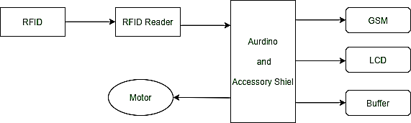

**Working of RFID System:**

Every RFID system consists of three components: a scanning antenna, a transceiver, and a transponder. When the scanning antenna and transceiver are combined, they are referred to as an RFID reader or interrogator. There are two types of RFID readers — fixed readers and mobile readers. The RFID reader is a network-connected device that can be portable or permanently attached. It uses radio waves to transmit signals that activate the tag. Once activated, the tag sends a wave back to the antenna, where it is translated into data.

The transponder is in the RFID tag itself. The read range for RFID tags varies based on factors including the type of tag, type of reader, RFID frequency and interference in the surrounding environment or from other RFID tags and readers. Tags that have a stronger power source also have a longer read range.

**RFID Module:**

* The generally used RFID module is RC522 which falls under High frequency Passive RFID system.
* It is mostly used with microcontrollers like Arduino, PIC (Peripheral Interface Controller), AVR (Alf (Nils Alfred) and Vegard (Wollan) Risc) and other microcontrollers that support communication protocols like
  + SPI (Serial Peripheral Interface is a synchronous serial communication protocol commonly used for short-distance communication between microcontrollers, sensors, and other peripherals)
  + IIC (Inter-Integrated Circuit is a multi-master, multi-slave, serial communication protocol, widely used for connecting microcontrollers, sensors, and other integrated circuits)
  + USART (Universal Synchronous Asynchronous Receiver Transmitter is a versatile serial communication protocol used for both synchronous and asynchronous data transfer between microcontrollers and other devices).
* Its interface is simple and has readily built libraries for Arduino. RC522 has a capability of reading the data from a tag as well as writing the desired info into the tag. It is very cheap and is easily available.

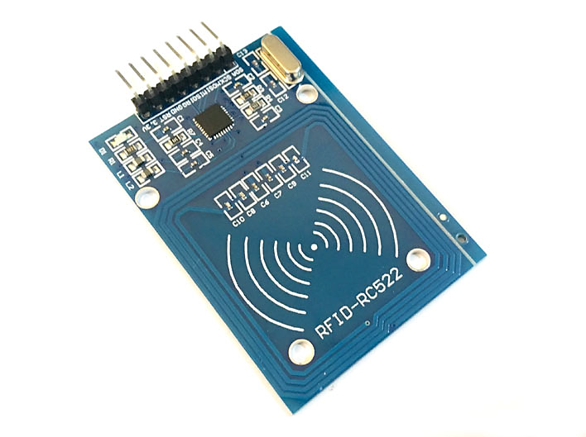

***RFID Module Pin Description:*** Typically, an RFID module comes with 8 pin RFID readers namely VCC, GND, IRQ, RST, MISO/SCL/Tx, MOSI, SCK and SS/SDA/Rx. Let us now discuss about the significance of each pin briefly.

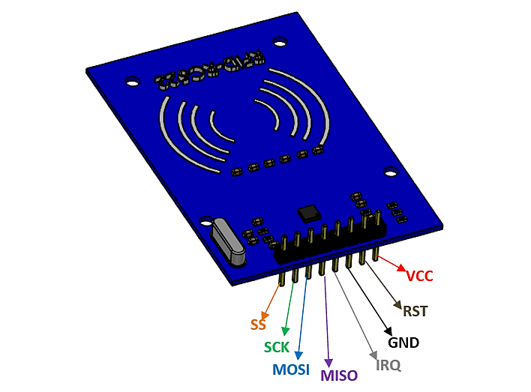

1. VCC: To run the module, the allowable voltage is up to 3.3V. Unlike most of the modules RC522 does not accept 5V as an input.
2. GND: As we know that to make a closed circuit GND terminal is required.
3. IRQ (Interrupt Request): It goes high when a RFID tag comes into the proximity of RFID reader. It helps in interrupting the microcontroller to pause (or perform) the task as designed by the engineer.
4. RST (Reset): It is an active low pin. When logic 0 is applied to the pin, the RFID reader will be switched OFF.
5. MISO (Master in Slave Out): In a SPI (Serial Peripheral Interface), multiple peripheral devices (Slave) are being communicated with the microcontroller (Master) quickly. So, MISO is used to send the data to the master (microcontroller) from the salve (peripheral device).
6. MOSI (Master Out Slave In): Like the MISO, using MOSI pin Master can send the data to the peripheral devices.
7. SCK (Serial Clock): To synchronize the data transmission between the master and slave SCK pin is used which generates clock pulses.
8. SS (Slave Select): In case if the slave devices are more than one, the SS can be used to select the desired device when required.

***Features of RFID Module***

* Host interfaces supported are SPI, RS232 serial UART (Recommended Standard 232) and IIC.
* Typical operating distance in Read/Write mode is up to 50 mm based on the size of antenna size and tuning.
* Reset with low power function for power efficiency.
* Interrupt modes are flexible for interfacing with microcontroller when multiples devices must be connected.
* 2.5 V to 3.3 V operating voltage.
* Internal self-test for testing the device by itself when powered ON to check whether the system is working as expected or not.

Note: The features and pin description discussed here is applicable only to RC522 RFID module.

**Features of RFID:**

* An RFID tag consists of two-part which is a microcircuit and an antenna.
* This tag is covered by protective material which acts as a shield against the outer environment effect.
* This tag may active or passive in which we mainly and widely used passive RFID.

**Advantages of RFID:**

* It provides data access and real-time information without taking too much time.
* RFID tags follow the instruction and store a large amount of information.
* The RFID system is non-line of sight nature of the technology.
* It improves the efficiency, traceability of production.
* In RFID hundreds of tags read in a short time.

**Applications of RFID:**RFID technology has a wide range of applications across various industries due to its ability to efficiently identify, track, and manage objects and assets. Here are some common applications of RFID:

1. Retail Inventory Management:
   * RFID is extensively used in retail to improve inventory accuracy and reduce stockouts.
   * Retailers can track the movement of products from the stockroom to the sales floor, enhancing supply chain visibility.
   * It enables quick and accurate inventory counts, reducing manual labor and improving stock replenishment.
2. Access Control and Security:
   * RFID cards, key fobs, or badges are employed for access control to buildings, offices, and secured areas.
   * These systems provide a convenient and secure way to manage and restrict entry to authorized personnel.
3. Asset Tracking and Management:
   * Many organizations use RFID to track and manage valuable assets, such as laptops, medical equipment, tools, and vehicles.
   * Asset tracking minimizes loss, theft, and misplacement, thereby improving asset utilization and maintenance.
4. Supply Chain and Logistics:
   * RFID is a game-changer in logistics, where it helps track products, containers, and pallets throughout the entire supply chain.
   * It offers real-time visibility into the movement of goods, reducing errors and enhancing supply chain efficiency.
5. Manufacturing and Production Control:
   * RFID systems are utilized in manufacturing to monitor the location and status of components, work-in-progress, and finished products.
   * This optimizes production processes and ensures the quality of goods.
6. Library and Media Management:
   * Libraries use RFID to automate book check-out and return processes, as well as to manage media, such as CDs and DVDs.
   * Patrons can easily locate items, and libraries benefit from improved inventory control.
7. Healthcare and Medical Equipment Tracking:
   * Hospitals use RFID to manage medical equipment, track patient records, and ensure proper medication administration.
   * It enhances patient safety and the efficient utilization of resources.
8. Agriculture and Livestock Management:
   * RFID tags are used to track livestock, monitor the health and location of animals, and manage agricultural equipment and inventory.
   * It helps optimize farming practices and resource allocation.
9. Waste Management:
   * RFID is employed in waste collection and recycling to optimize routes, manage bins, and track waste containers.
   * This improves the efficiency of waste collection services.
10. Airport Baggage Tracking:
    * RFID tags on luggage and baggage ensure efficient tracking and reduce the risk of lost or mishandled baggage.
    * Passengers can monitor their luggage's status in real-time.
11. Pharmaceuticals and Healthcare:
    * RFID is used to track pharmaceuticals and medical supplies in the supply chain.
    * It helps in combating counterfeiting, ensuring product authenticity, and monitoring the cold chain for sensitive medications.
12. Food Safety and Traceability:
    * In the food industry, RFID is used for tracking and tracing food products from farm to table.
    * It aids in identifying and managing the source of contamination and ensuring product safety.
13. Tracking shipping containers, trucks and railroad, cars.
14. ID badging.
15. Attendance management in office/schools.
16. Avoid fraudulent/stolen products from malls and supermarkets.
17. In constructions industries RFID technology can be used to manage materials.
18. Used in Real Time Location systems (RTLS) for tracking the location of a particular asset or an employee.
19. Used to lock and unlock the doors.

**Disadvantages of RFID:**

* It takes longer to program RFID Devices.
* RFID intercepted easily even it is Encrypted.
* In an RFID system, there are two or three layers of ordinary household foil to dam the radio wave.
* There is privacy concern about RFID devices anybody can access information about anything.
* Active RFID can costlier due to battery.

**Questions:**

* Knowledge Level (Remember):
  + What does RFID stand for, and how does it differ from traditional barcode systems in terms of data capture?
  + What is the read range of an RFID system, and how is it determined? Provide an example of a situation where a long-read range might be preferable.
* Comprehension Level (Understand):
  + Explain the basic components of an RFID system, including RFID tags, readers, and the middleware layer. How do these components work together to track and manage assets?
  + Explain the difference between UHF (Ultra-High Frequency) and NFC (Near Field Communication) RFID technologies in terms of their communication range and use cases.
* Application Level (Apply):
  + If you were tasked with implementing an RFID-based inventory management system for a retail store, what specific RFID tags and readers would you select, and why?
  + Suppose you are implementing an RFID-based access control system for a corporate office building. What security measures and encryption techniques would you employ to protect against unauthorized access and data breaches?
* Analysis Level (Analyze):
  + Analyze the advantages and disadvantages of using passive RFID tags compared to active RFID tags in logistics and supply chain management. Under what circumstances would each type be preferred?

Analyzing the advantages and disadvantages of using passive RFID tags compared to active RFID tags in logistics and supply chain management helps in making informed decisions about which technology to use in different scenarios. Here's an assessment of both types and when each may be preferred:

**Passive RFID Tags:**

*Advantages:*

1. **Lower Cost:** Passive RFID tags are more cost-effective than active tags, making them suitable for large-scale deployments.
2. **No Battery Maintenance:** Passive tags do not have a battery, eliminating the need for battery maintenance or replacement.
3. **Small Form Factor:** Passive tags are typically smaller and lighter, making them suitable for tracking smaller items or integrating into packaging.
4. **Low Maintenance:** Since they have no batteries, passive tags require less maintenance and have a longer operational life.

*Disadvantages:*

1. **Shorter Read Range:** Passive tags have a shorter read range compared to active tags, limiting their use for tracking items at a distance.
2. **Less Data Storage:** Passive tags usually have limited memory capacity, which may be insufficient for storing detailed item information.
3. **Limited Autonomous Functionality:** Passive tags rely on the reader's power to function, so they can't transmit data autonomously, which may limit real-time tracking capabilities.

**Active RFID Tags:**

*Advantages:*

1. **Longer Read Range:** Active tags have a longer read range, making them suitable for tracking items at a distance or in large areas.
2. **Autonomous Operation:** Active tags have their own power source (usually a battery), enabling them to transmit data autonomously at set intervals.
3. **Higher Data Storage:** Active tags typically have more memory, allowing for the storage of additional item information.
4. **Real-Time Tracking:** Active tags can provide real-time tracking and monitoring of items.

*Disadvantages:*

1. **Higher Cost:** Active RFID tags are more expensive due to their additional features and power source, making them less cost-effective for widespread use.
2. **Battery Maintenance:** The battery in active tags needs periodic replacement or recharging, which can be a logistical challenge.
3. **Larger Form Factor:** Active tags are usually larger and heavier, which may not be suitable for certain items or packaging.

**When to Prefer Each Type:**

* **Use Passive RFID Tags When:**
  1. Cost is a primary concern, and a cost-effective solution is needed for tracking a large number of items.
  2. The items to be tracked are in close proximity to RFID readers.
  3. Smaller form factors or lightweight tags are required.
  4. The items do not require real-time tracking and monitoring.
* **Use Active RFID Tags When:**
  1. Tracking items over longer distances or in larger areas is essential.
  2. Real-time tracking and monitoring are critical for supply chain visibility.
  3. Items require frequent or autonomous reporting of their status and location.
  4. The cost is less of a concern compared to the need for advanced functionality.
  + Analyze the environmental factors and interference sources that can affect the performance of an RFID system in a warehouse. How can these challenges be mitigated to ensure reliable operation?
* Evaluation Level (Evaluate): Evaluate the ethical implications of RFID technology, particularly in terms of privacy concerns. How should organizations balance the benefits of RFID with privacy protection for individuals?
* Synthesis Level (Create): Design a flowchart illustrating the data flow and communication between RFID tags, readers, and the central database in a healthcare setting where RFID is used to track patient records and medication administration.